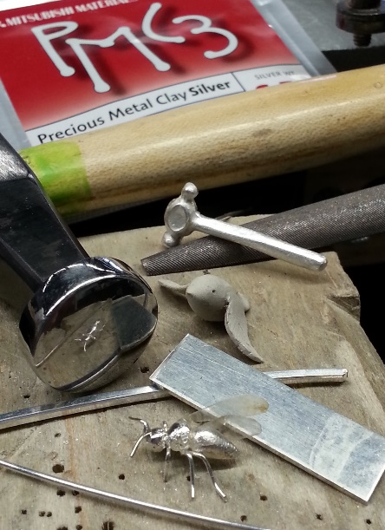
Metal Clay for Metalsmiths?
An article by Julie Sanford
It’s hard to believe that Silver clay has been around for more than 20 years. I consider myself a fabricator of jewelry; I build jewelry using raw materials and traditional goldsmithing techniques. Very little of my work is cast, and I don’t do many multiples. My work is hand to metal. When PMC fine silver clay came along in the late 90’s I was more than intrigued, I was excited! I knew metal and I knew clay. I grew up with a family ceramic shop in the basement of our home, and clay was basically my undeclared minor in college. Plus, this new metal clay was being promoted by the guy who wrote my college jewelry class required textbook, Tim McCreight, so it had to be a legitimate metals medium, right? I purchased my first metal clay in 1998, complete with the VHS tape tutorial, and was off to explore this strange new metal…clay.
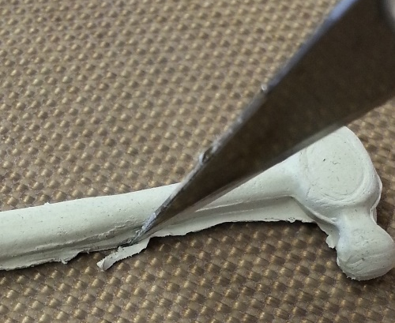
20 years later…. Today I have an extremely fond and high regard for well-designed metal clay jewelry and the artists who have perfected their skills in the medium. I know Metal clay gets a bad rap from a lot of traditional metalsmiths as being a quick and easy way to make jewelry. But there are hundreds of exceptional examples of amazing, well-crafted and technical work in metal clay. Over the years I’ve used it in a variety of ways and have had wonderful and sometimes surprising results. What I’ve found is that having the metal clay option in the studio can be a lifesaver when you can’t fabricate yourself out of a challenging design. It can also be just what you need when you don’t have the time or resources to cast.
Let’s take a very brief look at what metal clay is and then I’ll show you how I’ve used it at the bench. Metal clay is a soft pliable material made from fine metal dust and organic binders. It can be worked as wet clay by rolling, pinching, pressing, slicing, modeling, sticking parts together and even embedding other heat resistant objects such as metal, glass and stone. It can also be worked dry, by filing, carving, drilling, sanding and other subtractive sculptural and finishing methods. When you are done working and the piece is completely dry, it is fired. Firing, by kiln or by torch, removes the organic binders, fuses the fine metal particles (sintering) and the piece becomes a solid metal product. Metal clay is available in a variety of formulas from several manufacturers. I prefer fine silver clay. It’s easiest to fire, and the color blends well with my fabricated elements.
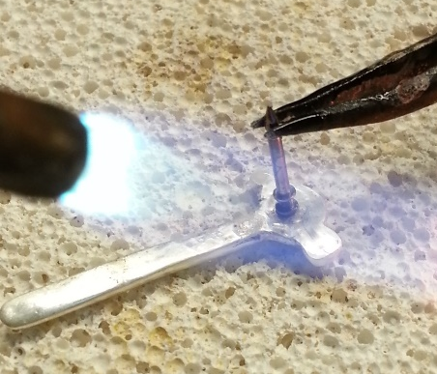
Since the three-dimensional, sculptural components in silver metal clay are all metal when they are fully sintered, they can be filed, drilled, sanded, burnished, soldered, patinated and polished, just as your fabricated or cast pieces. The tensile strength and density vary by which variety of clay you use, and most varieties do not bend and forge like milled or cast metal. The sintered metal clay pieces should be burnished well at the joins before soldering, but otherwise, fabricating with sintered metal clay parts is about as easy as using cast or pre-fabricated components in your work.
Although fabrication has always been my main mode of production, metal clay has occasionally found its way into my work in some form or other over the years. I have used the metal clay medium to create everything from flat work to beads and hollow forms. What makes the most sense is to make things that can’t be easily fabricated, like sculptural forms, and to combine fabrication techniques with metal clay in a similar way that jewelers combine cast work with fabrication.
By learning to use multiple techniques in metals, exploring new mediums and advancing your skills, you gain the ability to develop and execute more interesting and complex compositions, your ideas can be more animated and your imagination becomes freer to explore new possibilities.
Now You See Me Now You Don’t
Julie Sanford
Sterling and Fine Silver

